Public Housing Blog Draft

The Department of Housing and Urban Development (HUD) proposed a rule in April 2019 that would restrict housing assistance for mixed-citizenship families. A revision to the Housing and Community Development Act of 1980, the policy proposal marks yet another way that the Trump administration is targeting immigrant families and undocumented immigrants. Restricted federal housing programs, public housing and project-based federal assistance allow “mixed citizenship” families, which are households that contain at least one member who is not a citizen and does not have qualifying immigration status, to be eligible for housing aid. Under the current system, households with undocumented immigrants or individuals with otherwise “ineligible” immigration status can receive subsidized or public housing, as long as at least one other member of the household is a citizen or has eligible noncitizen status, which includes individuals who are legal residents, refugees, or asylum seekers. These programs have prorated rental assistance, so families with “mixed” status pay higher rent to account for “noneligible” individuals (HUD, 2013; Affordable Housing Online). However, the proposal changes affordable housing qualifications to ban federal housing assistance for households with at least one undocumented or “ineligible” immigrant. The rule requires that every member of the household receiving federal housing assistance hold eligible immigration status (HUD, 2019).

Though Ben Carson, the HUD Secretary, has claimed that the new rule would cut down on long waiting lists for public housing, former secretary Julián Castro has asserted, “The bottom line is that our government is terrorizing families — first with ICE raids, now with evictions” (Karni & Shear, 2019). The proposal affects public housing, project-based rental assistance units, and Housing Choice Voucher (Section 8) recipients. According to HUD’s analysis, it would evict 32,000 households from their subsidized home, amounting to 108,000 people and 55,000 children (HUD, 2019). Though the policy still remains a [proposed rule in the Federal Register](https://www.federalregister.gov/documents/2019/05/10/2019-09566/housing-and-community-development-act-of-1980-verification-of-eligible-status), it signals that immigrant families are facing a growing risk of being ejected from federal housing assistance and permanently losing future eligibility.

But discrimination against immigrants and people of color is not a novel concept in the history of federal housing assistance. Since the 1930s, the federal government has provided various forms of housing assistance to low-income families to increase the affordability of housing, offering public housing and homeownership and rental housing assistance. In public housing, low-income tenants reside in housing developments owned and managed by local public housing agencies and pay a subsidized rental payment. In project-based rental assistance, HUD enters subsidy contracts with private developers to offer privately-owned subsidized housing for low-income families. However, governments and real estate agents promoted racial segregation through exclusionary and discriminatory housing policies, imposing racial restrictions on residences, engaging in redlining, and devaluing property based on the racial composition of residents. This legacy of state-sponsored racial segregation continues to influence the racial dynamics of cities and public housing, which continues to be one of the largest federal housing programs and houses over 950,000 households (Center on Budget and Policy Priorities, 2019).

Using data from the 2017 American Housing Survey, which is sponsored by HUD and conducted by the Census Bureau, we conduct an analysis of households in “brick-and-mortar” housing aid, or public housing and project-based assistance, by a variety of demographic factors.

Black or African American households have the greatest percentage in public housing, with 6.4% (± 0.6) of households in public housing, and White alone households have the smallest percentage in public housing, at 1.1% (± 0.1). As expected, racial minority and Hispanic or Latinx households are much more likely to be in public housing than While alone households. Additionally, three times as many female-headed households than male-headed households rely on public housing, around 3% as compared to 1%. Higher rates of poverty among women than among men, as well as occupational segregation and housing discrimination may drive these trends (Re:Gender, 2016). While White alone households headed by men are the least likely to be in public housing, Black or African American households headed by women are the most likely to be in public housing, over 10 times more likely than White male-headed households. Households that are AIAN alone, Hispanic of any race, and Asian alone, and with either female or male householders, are much more likely to be in public housing than are White alone households with a male householder.[1]

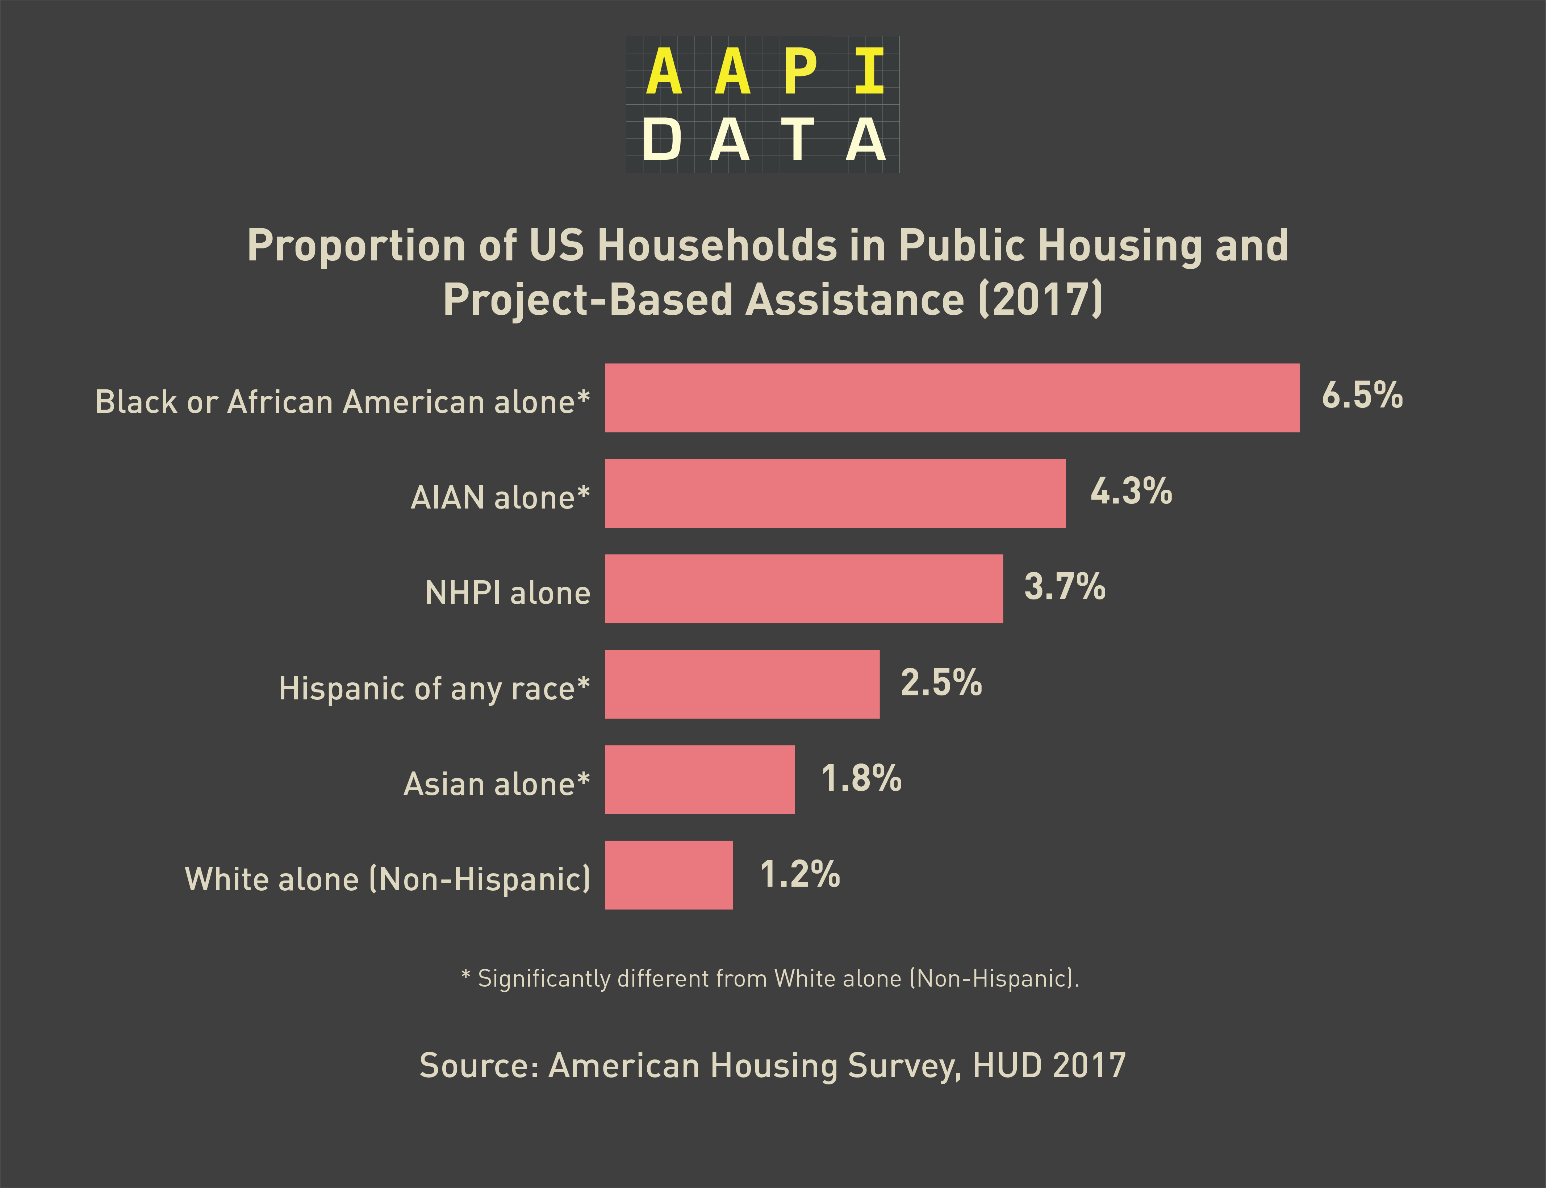

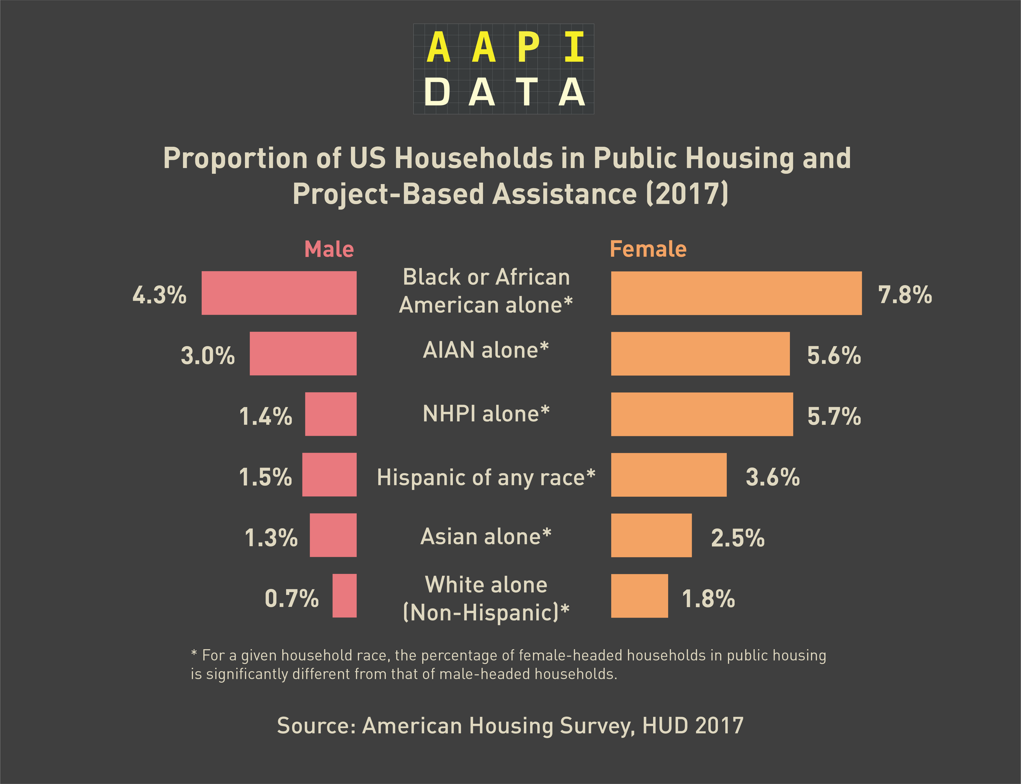

The education level of the householder also impacts the likelihood that a household will be in public housing and project-based rental assistance. Our analysis confirms that households with heads that have higher levels of educational attainment are less likely to live in public housing. While around 6% (± 0.6) of households with heads that have less than a high school education live in public housing, only 0.4% (± 0.1), of households with heads that have a Bachelor’s degree or higher reside in public housing. Even across racial and ethnic groups, householders with below a high school education level are much more likely to rely on public housing. While this may be tied to income levels, it may also be a result of differences in literacy in the housing application process.

We find that households comprised of members whom are all citizens, both naturalized and native, are over 50% more likely to live in public housing than are households with at least one citizen, but without all citizen members, with 2.0% (± 0.1) as compared to 1.3% (± 0.4), respectively. However, there are a similar proportion of households without any citizens in the household and those with at least 1 citizen but without all citizen members that live in public housing.

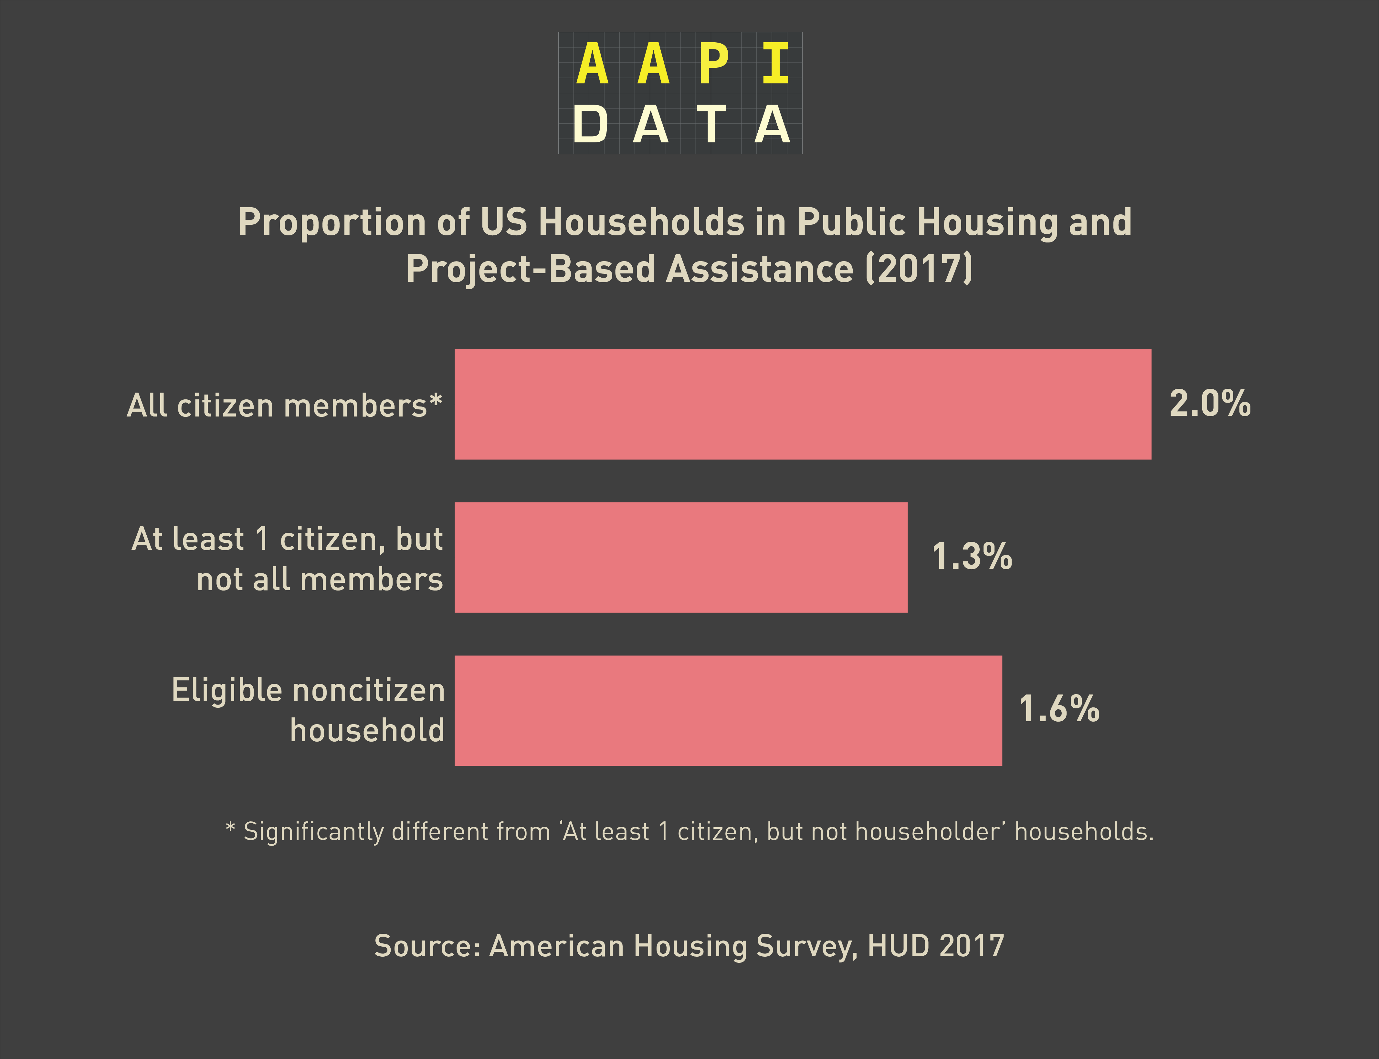

Trends in reliance on public housing by household citizenship status differ slightly by race, with significant differences for Asian and Hispanic/Latinx households. Asian and Hispanic/Latinx households in public housing and project-based rental assistance face the largest threat to attacks on immigration and citizenship status. Over a quarter of Asian households and one-fifth of Hispanic/Latinx households in public housing or project-based assistance have at least one member who is not a citizen. Over 16% and almost 5% of Asian and Hispanic/Latinx households in public housing and project-based assistance, respectively, do not have any citizens.

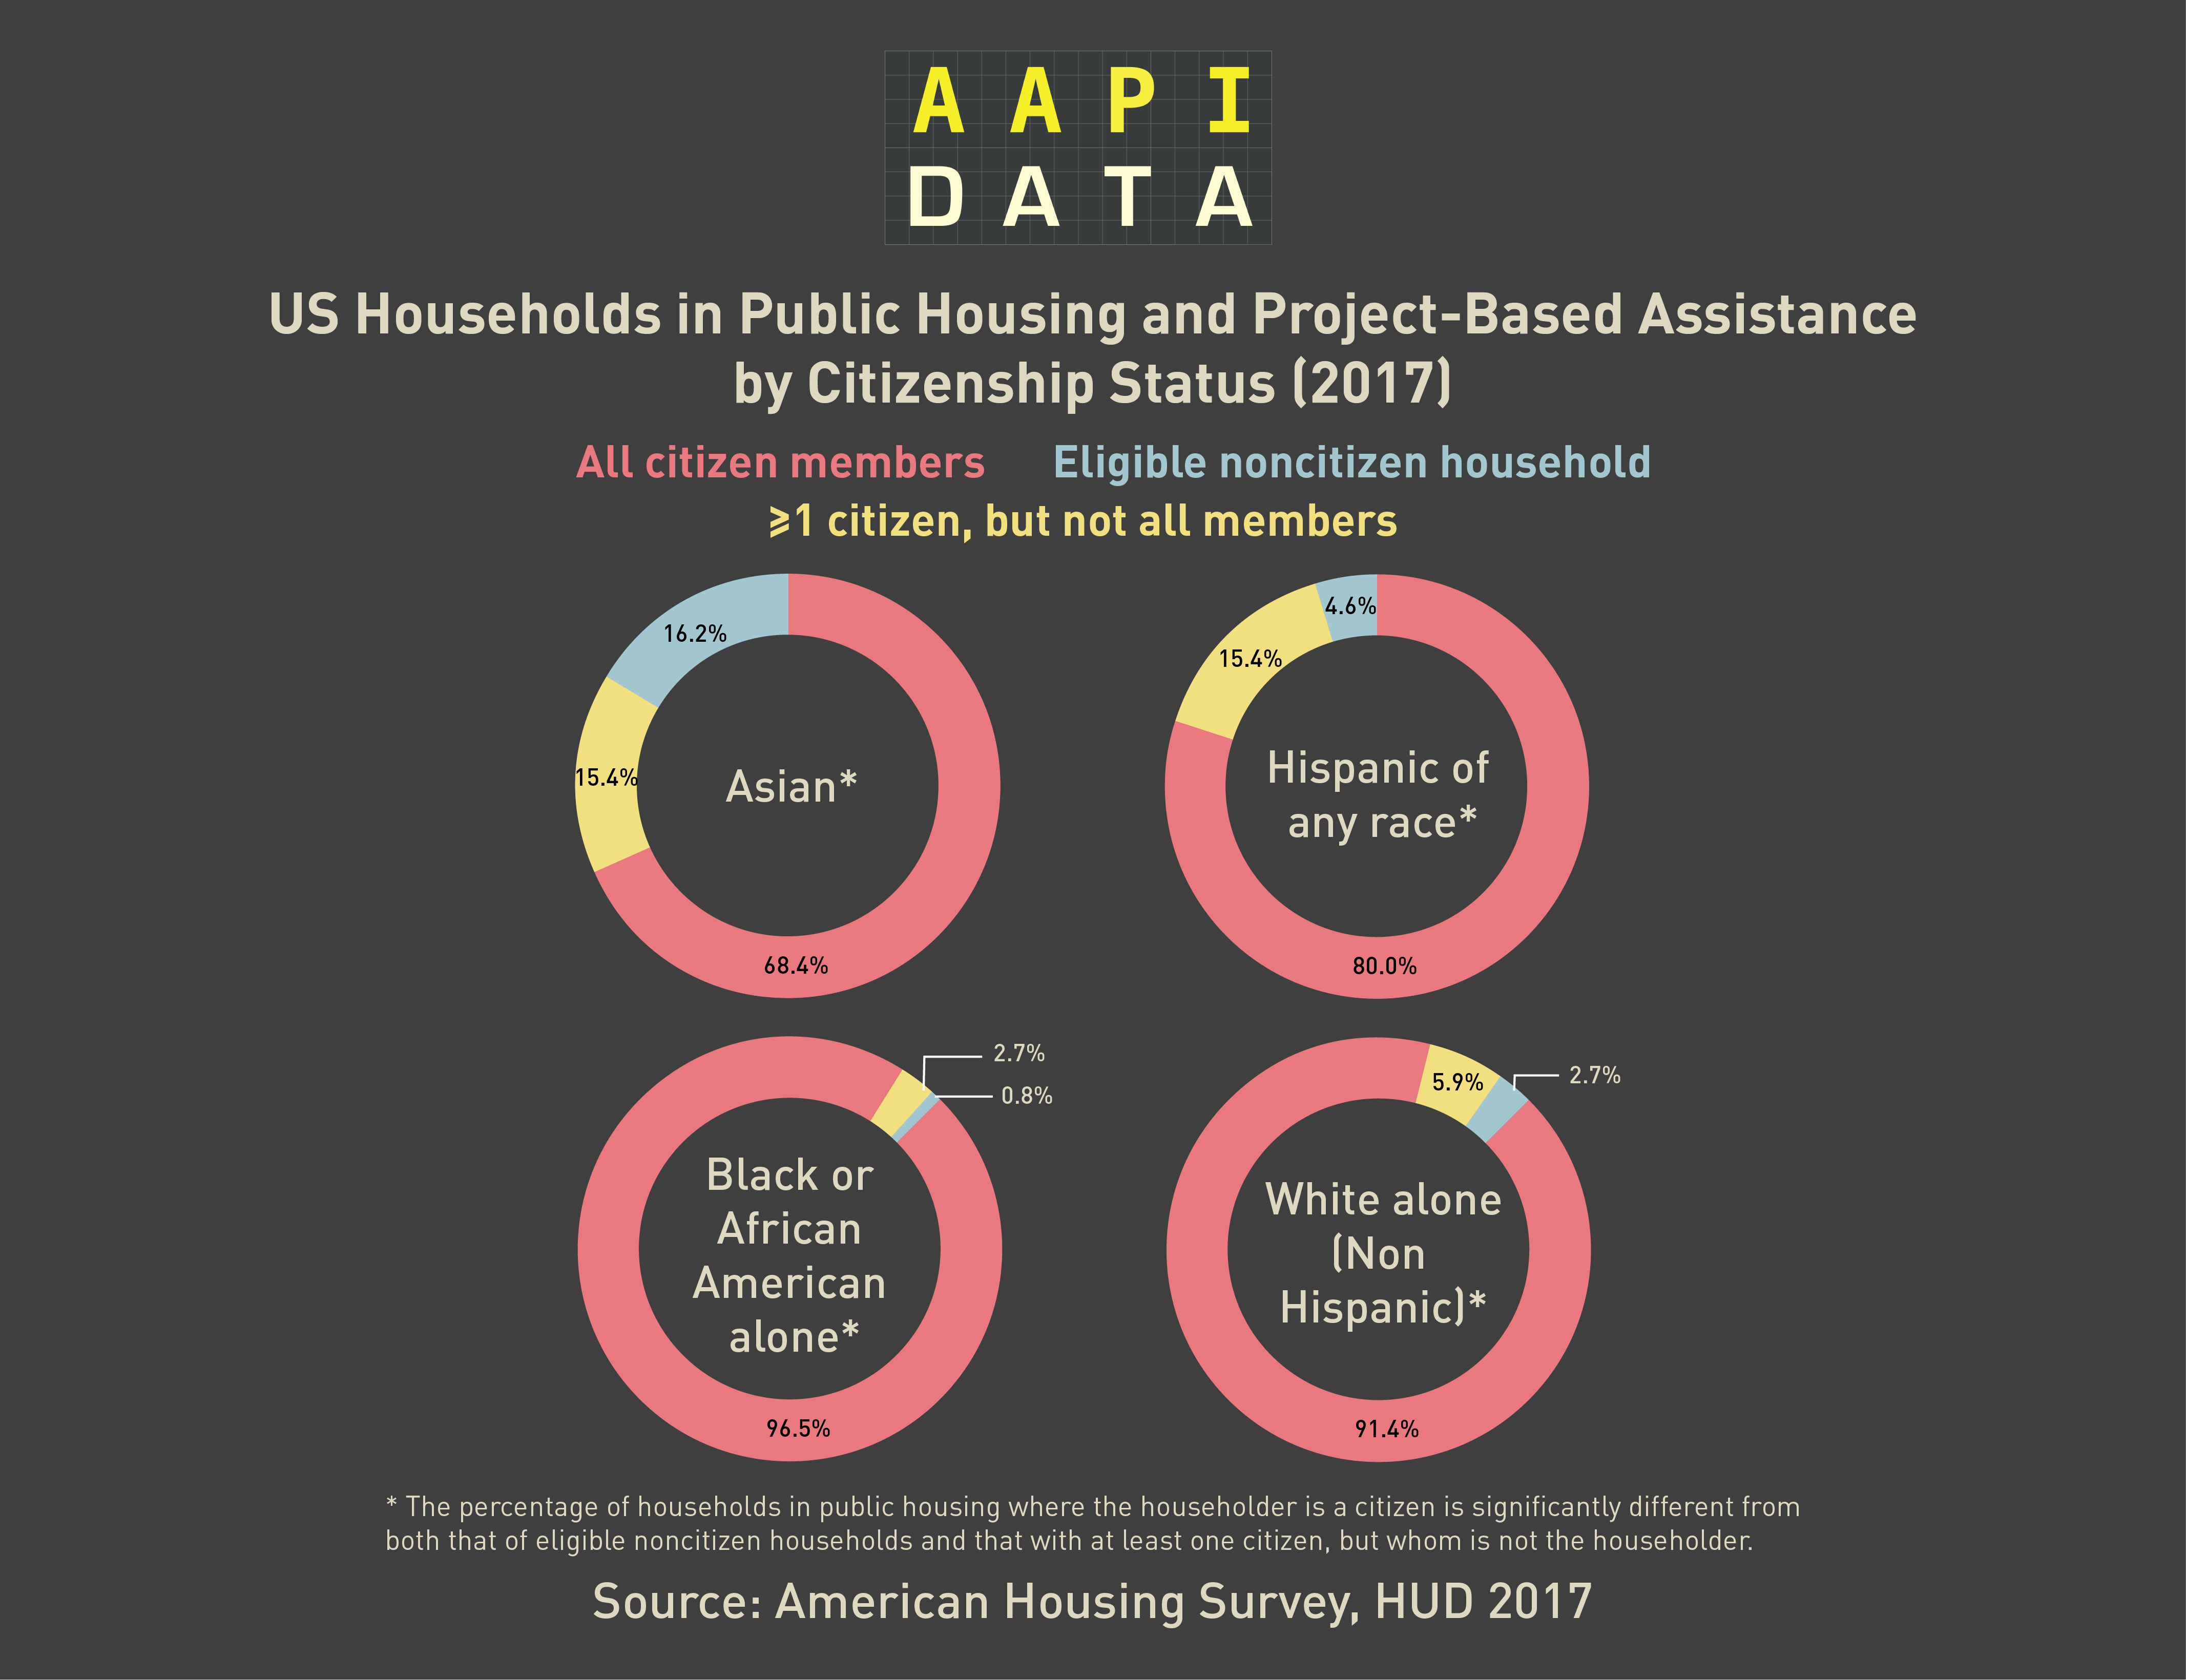

Sources

Affordable Housing Online. *Housing for eligible noncitizens*. Affordable Housing Online. https://affordablehousingonline.com/guide/housing-for-immigrants/eligible-noncitizens

Center on Budget and Policy Priorities. (2019, December 10). *Federal rental assistance fact sheet*. https://www.cbpp.org/sites/default/files/atoms/files/12-10-19hous-factsheet-us.pdf

Karni, A. & Shear, M. D. (2019, April 17). HUD moves to limit public housing aid for undocumented immigrants. *The New York Times*. https://www.nytimes.com/2019/04/17/us/politics/hud-public-housing-immigrants.html

Re:Gender. (2016, January). *A gender lens on affordable housing*. https://www.icrw.org/wp-content/uploads/2016/11/gender_lens_on_affordable_housing_by_regender_final-1.pdf

United States Department of Housing and Urban Development. (2013). *HUD Handbook 4350.3:*

*Occupancy requirements of subsidized multifamily housing* programs. https://www.hud.gov/sites/documents/43503C3HSGH.PDF

United States Department of Housing and Urban Development. (2017). *American housing survey* *2017 national public use file (PUF)* [Data file]. United States Census Bureau. https://www.census.gov/programs-surveys/ahs/data/2017/ahs-2017-public-use-file--puf-/ahs-2017-national-public-use-file--puf-.html

United States Department of Housing and Urban Development. (2019, April 15). *Regulatory impact analysis: Amendments to further implement provisions of the Housing and Community Development Act of 1980*. https://nlihc.org/sites/default/files/2019-05/Noncitizen-RIA-Final-April-15-2019.pdf

1. Estimates for NHPI households have significant margins of error for both female and male householders, both of which are above 95%.